# Chapter-1 Introduction

## 1.1 Introduction of the system

Now a days we live in the age of the information communication and technology. From day to day life we need the help of the technology. This is the revolutionary time of the computer technology .At this time information of the world is very important and valuable resource for the people.

So, online news portal is the online version of the newspaper and one of the source or the web application that gives information about the world. Using this app users will directly access online news and information on their mobile phones, PDAs, Laptop, PCs and tablets anywhere and at any time. Without payment or login user can give suggestion and can also give us feedback as their perception.

## 1.2 Background to the system

The main theme of these project is to give information of the news which is happening in the world and is updated every single minute in real time.

I will make new system which include and implement various unique features to make a step ahead. As the website is online based user can get information and can use free through the web application.

### 1.2.1 Problem statement

People use to read the newspaper it used to be delay and everyday people has to pay for it so, to overcome this problem I have been using the online news portal so, that user can get information in time without any cost.

## 1.3 Justification of the project

The trend of the reading paper-based newspaper is decreasing day by day due to the growth of the internet. In Nepal reading online news has been streaming and been trending in present days. This system or app helps the users to get in touch with the news of the world and be updated regularly. It makes online media very efficient and reliable due to fast coverage of news throughout the world. So, this is applicable for the user for the development of the project.

## 1.4 Overview of the project

This project will be implementing various features which provide fast update, impressing user interface (UI) and authentic news. Thus, it is user friendly.

# Chapter-2 Scope

## 2.1 Aims of the project

The aim of this project is to give access to the news of the different countries and provide instant update to the news in the development of the project.

## 2.2 Objectives of the project

Main objectives of this project are as follows:

* The objectives of this project is to provide everyday news.
* The objectives of this project is to develop a web application for online newspaper website.
* The objectives of this project is to use of various technologies to get required oriented information more quickly, easily and attractively.
* The objectives of this project is that anyone, anywhere and at any time knows about the information by internet.
* Faster discrimination of information in a timelier manner.
* It is used to provide all type of instant and important news which is related to business, sports, education and much more.

## 2.3 Features to be included

* Authorized user can add, delete or update the news or information on the website.
* User can login/register their new account to get up to date about the news.
* Readers can express their views on particular issue, like or dislike some opinion or can raise their voice by giving reviews or commenting on the website.
* Frequent news can be updated.

## 2.4Overview of the scope

Our main scope is to focus on the aims. Our aim is to focus on the features that is included on this web application and the objectives that is implement through the aims of the project.

# Chapter-3 Development Methodology

## 3.1 Methodology to be used

The waterfall model is the earliest SDLC approach that was used for software development. It is also referred as linear-sequential life cycle model. It is very simple to understand and use.so, I have used waterfall model in this project this means each step be completed before implementing the next step. Each step is important for the development of the project.

Following model is the representation of the different phases of the waterfall model.

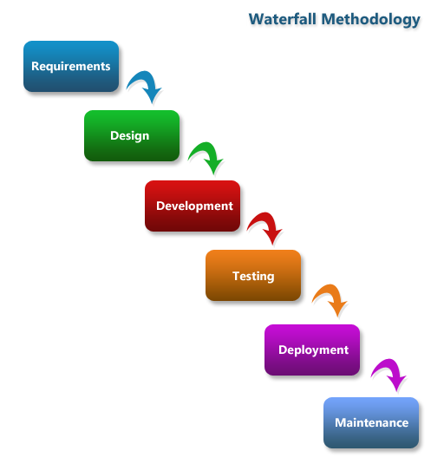

At first the steps includes all the requirements needed for development. In second step those requirements are used to design the system and at third step development or implementation is used for creating the system. System is tested during the testing and the system is distributed and finally maintenance are done in last step.

## 3.2 Design pattern

Model View Controller (MVC) design pattern is used in this project. It is very effective and modern design pattern in the development. In MVC pattern both web and desktop-based language are used.

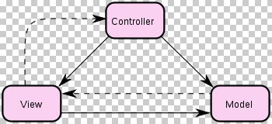

Model: It represents the shape of the data and maintains the data of application.

View: It is the user interface and display data using model to the user.

Controller: It handles the user request and renders the appropriate view with the model data as a response.

## 3.3 System Architecture

System Architecture is a response to the conceptual and practical difficulties of the description and the design of the complex systems. System Architecture helps to describe consistently and design efficiently complex system.

System Architecture will often rely on a tool called an architecture framework.

This system used 3-tier architecture. This architecture explain the system architecture which contain 3 major reasonable computing. Following are the diagram of the 3-tier architecture:

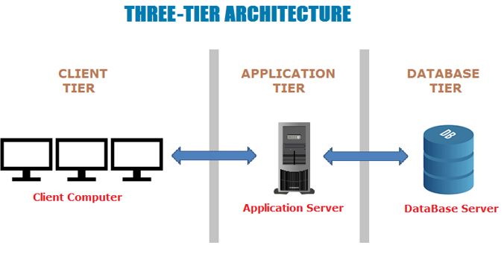

Fig:Three-Tier Architecture

Client Tier: It is the front-end coating in the software architecture. User interface is used in this project. The client tier in the three-tier architecture model is usually a web browser.

Application tier: It is system architecture that usage an application server and procedures the professional logic for the application.

Database tier: It is the database management system that deliver admittance to application data.

# Chapter-4 Project scheduling or plan

## 4.1 WBS (Work Breakdown Structure)

Work Breakdown Structure is a key project deliverable that organizes the team's work into manageable sections. Project work breakdown structures can also be used to identify potential risks in a given project. A project budget can be allocated to the top levels of the work breakdown structure, and department budgets can be quickly calculated based on the each project's work breakdown structure.

Final Documentation

Proposal

Testing

Coding

Design

\

Analysis

Unit testing

System creation

Activity Diagram

Analysis

User interaction

Database Design

White box testing

Scope

Final Description

Interface Design

Database Formation

Use case diagram

WBS

Black box testing

Structure design

Requirement analysis

Risk management

Integration testing

Response design

Config management

Interface analysis

submission

## 4.2 Milestones

|  |  |  |
| --- | --- | --- |
| Milestone | No. of Days | Date |
| **Proposal**  Scope, Aims, features  WBS  Risk Management  Config management  Submission | **16**  4  3  4  4  1 | **June 16th-july 1st,2019**  June 16th –June 20th,2019  June 21st- June 23th,2019  June 24th-June 27th,2019  Jun 28th-July 1st,2019  July 1st ,2019 |
| **Analysis**  Activity Diagram  Class Diagram  Requirement Analysis  Interface Analysis | **28**  7  7  7  7 | **July 1st - July 29th,2019**  July 1st -July 7th,2019  July 8th-July 14th,2019  July 15th-July 22rd,2019  July 23th-july 29th,2019 |
| **Design**  Database Design  Interface Design  Structure Design  Response Design | **31**  8  8  7  8 | **July 30th-Aug 29th,2019**  July 30th-Aug 6th,2019  Aug 7th-Aug 14th,2019  Aug 15th-Aug 21th,2019  Aug 22th-Aug 29th,2019 |
| **Implementation and coding**  Database formation  System Creation | **22**  10  12 | **Aug 30th-Sep 20th,2019**  Aug 30th-Sep 10th,2019  Sep 11th-Sep 20th,2019 |
| **Testing**  Unit testing  Black box Testing  White box Testing  Validation Testing | **10**  2  3  4  1 | **Sep 21st -Sep 30th,2019**  Sep 21st -Sep 22nd ,2019  Sep 23rd-Sep 25th,2019  Sep 26th-Sep 29th,2019  Sep 30th,2019 |
| **Final documentation**  User interaction  Final description | **12**  8  4 | **Oct 1st -Oct 12th,2019**  Oct 1st – Oct 8th,2019  Oct 9th-Oct 12th,2019 |

* Project management(16 days)
* Scope, Aims, features(4)
* WBS(3)
* Risk Management(4)
* Config management(4)
* Submission(1)
* Analysis(28 days)
* Activity Diagram(7)
* Class Diagram(7)
* Requirement Analysis(7)
* Interface Analysis(7)
* Design(31 days)
* Structural diagram(7 days)
* Response diagram( 8 days)
* Interface design( 8 days)
* Database design( 8 days)
* Implementation(22 days)
* Database formation(10 days)
* System creation( 12 days)
* Testing(10 days)
* Unit testing(2 days)
* Black box testing(3 days)
* White box testing(4 days)
* validation testing(1 days)
* **Final Documentation(12 days)**
* User Interaction(8 days)
* Final Description(4 days)

## 4.3 Gantt chart

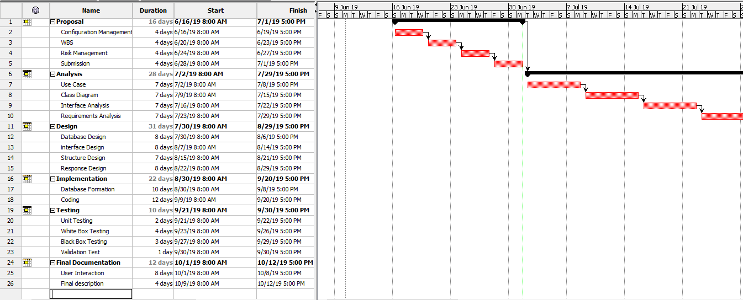

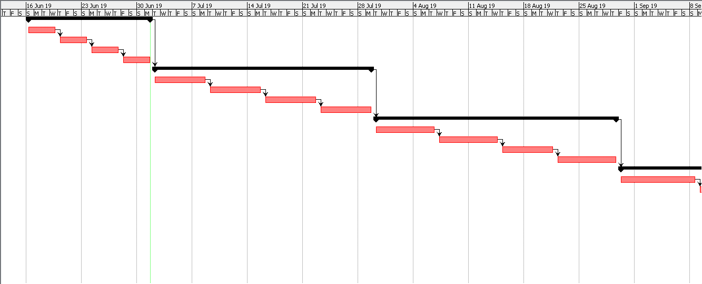

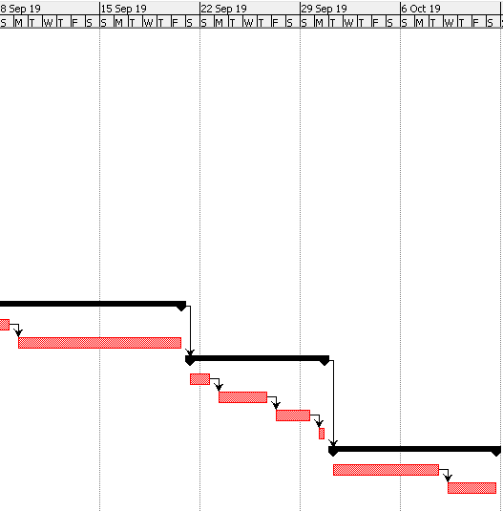

# Chapter-5 Risk Management

To solve the consequences we have to declare risk management which is the process that identifies, analyze and respond it to any risk that come from the software development life cycle to help the project to remain on track and meet its aim or requirements. It is our duty to identify the risk and solve them so that in further development the problem doesn’t arise.

Some risk management system are:

1. Identifying the risk.
2. Assessing the risk.
3. Controlling the risk.
4. Reviewing the risk.

Backup server will be setup to avoid such risk of loss of the data in the project. If the data is lost and isn’t stoppable then time will be allocated for new application of the development. Work can be divided by transferring the risk to the partner to solve the problem of the risk.

Table for risk likelihood

|  |  |
| --- | --- |
| **Likelihood** | **Value** |
| Low | 1 |
| Medium | 2 |
| High | 3 |

Table for Risk Consequences

|  |  |
| --- | --- |
| **Consequences** | **Value** |
| Low | 1 |
| Very Low | 2 |
| Medium | 3 |
| High | 4 |
| Very High | 5 |

Following table shows how much likelihood and consequences are determined by the impact of the event and it solutions:

|  |  |  |  |  |  |
| --- | --- | --- | --- | --- | --- |
| **No.** | **Event** | **Likelihood** | **Consequences** | **Impact** | **Solution** |
| 1 | Lack of user friendliness | 2 | 3 | 6 | Design should be done according to the user’s interest. |
| 2 | System crash | 2 | 4 | 8 | Controller tools must be chosen and must have auto backup system. |
| 3 | Malware/virus | 2 | 2 | 4 | Antivirus should be installed. |
| 4 | Poor time and estimation | 3 | 3 | 9 | Proper analysis should be done and coding, testing time should be allocated at first. |

# Chapter-6 Configuration Management

Configuration management (CM) is a [governance](https://searchcompliance.techtarget.com/definition/information-governance) and [systems engineering](https://whatis.techtarget.com/definition/systems-engineering-SE) procedure for confirming consistency between physical and logical resource in a working environment.

Benefits of the configuration management is configuration management tool can progress the system of government change-impact analysis, decreasing the outages affected by construction variations.

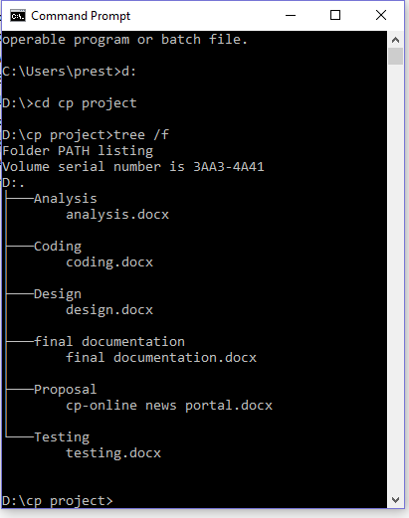

Fig:Project structure

# Chapter -7 Conclusion

This project will focus on giving information through the web application which include different features that helps user to interact with the world. Though it is user friendly that is easy in navigation bar. User can review their thought through comment. I have done this my best project a better performance and try to fulfill all the requirements.

# Reference:

1. En.wikipedia.org. (2019). *Riz Ahmed*. [Online] Available at: https://en.wikipedia.org/wiki/Riz_Ahmed [Accessed 1 Jul. 2019].
2. WorkSafe Queensland. (2019). *Four steps to manage hazardous manual task risks in the workplace*. [online] Available at: https://www.worksafe.qld.gov.au/news/2016/four-steps-to-manage-hazardous-manual-task-risks-in-the-workplace [Accessed 1 Jul. 2019].
3. Google.com. (2019). *3-tier system architecture images - Google Search*. [online] Available at: https://www.google.com/search?rlz=1C1LFSP_enUS767NP767&biw=1093&bih=526&tbm=isch&sa=1&ei=8L0ZXbKKAu_Yz7sP0aOs6A8&q=3-tier+system+architecture+images&oq=3-tier+system+architecture+images&gs_l=img.3...30506.30820..32105...0.0..0.147.281.0j2......0....1..gws-wiz-img.SED0N6rTz-U [Accessed 1 Jul. 2019].
4. Sahayogee, J. (2019). *Nepal News - 50 Websites for Online Breaking News & Headline Today*. [online] ImNepal.com. Available at: https://www.imnepal.com/online-news-websites-nepal/ [Accessed 1 Jul. 2019].
5. www.tutorialspoint.com. (2019). *SDLC Overview*. [online] Available at: https://www.tutorialspoint.com/sdlc/sdlc_overview.htm [Accessed 1 Jul. 2019].
6. Tutorialsteacher.com. (2019). *MVC Architecture*. [online] Available at: https://www.tutorialsteacher.com/mvc/mvc-architecture [Accessed 1 Jul. 2019].
7. Lix.polytechnique.fr. (2019). *What is Systems Architecture?* [online] Available at: https://www.lix.polytechnique.fr/~golden/systems_architecture.html [Accessed 1 Jul. 2019].